Acutouch Therapy

An advanced form of non-invasive acupuncture, adding the benefits of Magnetism, Far Infrared Rays and Anions

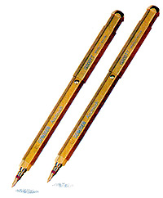

“Perhaps even one day it is possible that we shall be able to stimulate specific beneficial neurotransmitters non-invasively, and that needling itself could become obsolete.”

From:

“Acupuncture. A Scientific Appraisal”

edited by Edzard Ernest and Adrian White
(published in 1999)

This has now become possible with Acutouch Therapy
( Cheryl Gaynor B.Sc. Physio . C.Town )

Contents

Item | Page
Introduction | 3
Magnetism | 4
Far Infrared Rays | 16
Anions | 17
Using Acutouch Diagnostically | 19
Western Scientific Approach to Acupuncture | 25
Pain Mechanisms | 29
Segmental Acupuncture | 32
Acupuncture and the PNS | 35
Non-segmental Acupuncture | 36
Practical | 39
References | 40
Case Studies | 42

Introduction

Dr. Chi Kyung Kim, a successful South Korean engineer invented Genesen Acutouch, in 1994. Dr Kim developed the Acutouch pointers in response to a personal desire to help his wife who had suffered a massive stroke and was given no prospect of recovery by both western and eastern practitioners.

With his knowledge of physics he set about studying therapeutic phenomena known to enhance circulation and to beneficially affect the nervous system.

This resulted in the prototype, which brought his wife back to good health within a period of nine months.

From being previously unable to either walk or talk, she regained both these functions, following daily treatment with the Acutouch pointers.

International Quality Marks

Genesen Acutouch is manufactured to ISO 9002 standards and carries the CE certification as a Class 1 medical device.

Genesen Acutouch Pointers

Three key elements:

- Magnetism

- Far Infra Red Rays

3. Anions

Magnetism

After centuries of being considered as an old wives tale, magnetism is finally coming into its own.

We now know that fish are able to return to their spawning grounds by following the earth’s magnetic lines of force in the same way that birds do.

Similar results have been shown lately in beetles, crickets, bees, grasshoppers, and flies.

It has also been demonstrated that birds lose their ability to navigate when magnets are attached to them.

It was not long ago that an astute gardener discovered that he could rid his fields of cabbage moths by scattering magnet fragments among the plants. The moths became so disorientated that they left the property.

Magnetised water once thought ridiculous is becoming universally accepted. Water passed through strong magnetic fields is now being used in industry and medicine in Russia, France and the United States of America.

The Volga research Institute now irrigates huge areas with magnetized water. The water has been found to give a 28% increase in winter wheat, 17% in corn, 37% in cucumber and 32% in tomatoes.

Over the last 155 years scientists have recorded a decline in the strength of the earth’s magnetic field.

The effects of a decline in the magnetic field on human health was realized when early cosmonauts experienced bone calcium loss and muscle cramps when in space above the earth’s magnetic field for an extended time. When artificial magnetic fields were placed in the space capsule, the astronauts maintained their health to a much greater degree.

Today magnetism is in widespread usage in MRI’s, MEG’s, and other diagnostic techniques and yet in spite of this ready acceptance of magnetism as a diagnostic tool, it is still regarded with skepticism by some members of the medical profession when used for treatment purposes.

Natural therapies are often accused of playing a significant psychosomatic heal in healing.

However, the John Hopkins Treatment Pain Center tested the use of magnetic devices with a control group and found that only 13% were influenced by the placebo effect.

This is significantly lower than the 17% figure concurred with by the FDA in a series of rather elaborate tests by the Japanese for psychosomatic response or placebo effect for most types of therapy.

Where the placebo effect is lower than this it is usually due to actual physical or therapeutic effect. Magneto therapy has shown success rates of 70% and higher, depending on the ailment.

Studies in magnetism

“The Body Magnetic and Getting Started in Magnetic Healing”

Physiologist and physicist Dr Buryl Payne reports:

- Increased blood flow with resultant increased oxygen carrying capacity, both of which are basic to helping the body heal itself.

- Changes in migration of calcium ions, which can either bring calcium ions to heal a broken bone in half the usual time or help remove calcium away from painful arthritic joints.

- The high powered balance of various body fluids can be altered by magnetic fields.

- Hormone production from the endocrine glands can be either increased or decreased by magnetic stimulation.
Studies done by Dr Bassal from 1983-1990 show:

- Magnetic contact with human blood activates the iron contents and creates a weak electric current.

- The number of red blood corpuscles is increased and inactive and decayed arteries are strengthened.

- Movement of hemoglobin is accelerated and calcium and cholesterol deposits are held to a minimum.

- The process of ionization is hastened which alleviates the danger of blood clotting and stimulates the flow of blood to arteries and veins.

- Secretion of hormones and other fluids is promoted.

- Function of ANS is normalized and strengthened.

- Building up of new cells and rejuvenation of tissues.

Further studies show that:

- Magnets act as regulators by changing the intensity of electrical fields and corresponding magnetic fields.

- Magnetic fields cause bicarbonate bonds to break, producing hydroxides that create an alkaline pH and extra cellular fluid capable of absorbing far more oxygen than in an acidic pH environment.

- Magnetic field also raises the potential difference between external and internal fluids allowing nutrient channels to open more readily.

(Washnis and Hricak)

Orthopedic surgeon Dr Andrew Bassatt has demonstrated a success rate of 80% in healing of non-union bone fractures when treated with magnetic therapy.

Magnetism

It is necessary to be aware of the difference caused in the body of a negative magnetic field versus a positive magnetic field.

In relation to Acutouch therapy however this is not relevant due to the strength of magnetism used (i.e. 600 gauss)

What is important to understand is that the positive (providing the gauss strength is sufficiently low) + bipolar magnetic fields as used in Acutouch attract the negative polarity to the injury site by biofeedback and other mechanisms in order to heal.

For magnetic therapy we have a reasonable theory of a biofeedback effect where the brain causes increased negative magnetic energy to rush to the site of pain, energised by the injury itself or the irritant effect of a positive magnetic field.

It is believed by some that dual polarity magnets creates a pulsing type effect that treats more rapidly than single polarity magnets of similar gauss strength.

A higher gauss negative poled magnet might be required to create a similar response.

The negative polarity is the more effective long-term healer because it adds negative energy rather than taking it from other body sources.

Two mechanisms are involved when using Acutouch.

- The negative pole adds negative magnetic energy directly below it.

- The positive pole stimulates the body to send negative magnetic energy to the area (using a counterirritant effect).

In general -

The negative pole:

- Fights infection

- Supports biological healing

- Normalises ph acid-base balance

- Brings more oxygen into cells

- Relieves pain

The positive pole:

- Stimulates wakefulness

- Assists to jump start immobile muscles

- Is considered less effective on long term biological healing.

The circulatory system

Magnetism acts on paramagnetic elements in the body, especially the blood, and it is mainly through the circulatory system that the effects of magnetism are dispersed throughout the body.

Therefore, it is important to understand how the human circulation system functions.

The human body contains 5 to 6 litres of blood, which are pumped to every organ in the body.

Arteries, arterioles, and capillaries carry oxygen and other essential elements to those organs.

The same capillaries then take back the used blood, which carries toxins and waste products, and empty it into the veins.

On its way back to the heart, the blood goes through the kidneys, where it is filtered, then through the lungs, where it is recharged with oxygen.

The blood, now refilled with fresh oxygen, reaches the heart, from which it is sent off to the organs again.

Human blood is composed of blood cells (45%) and plasma cells (55%).

Blood cells contain mainly red cells (erythrocytes), white cells (leukocytes), and platelets.

A red cell functions like a small container for a substance called hemoglobin, which gives blood its particular colour.

A hemoglobin molecule contains enough iron (4 atoms/10,000) to make reds cells slightly paramagnetic and therefore subject to the effects of magnetic fields.

Moreover, red blood cells are the major oxygen transporters in the body. When the body’s red cell count is considerably diminished, or when the hemoglobin content of those cells, and consequently their iron content, is too low, the body does not receive enough oxygen to maintain an adequate level of energy.

Anemia is a condition where there is a loss of energy due to a lack of iron.

It has been shown that magnets can increase blood conductivity slightly, and ionized blood can improve blood circulation and stabilize high or low blood pressure.

Therefore, magnetized blood can carry more oxygen to the cells; in other words, it can make more energy available to tissues and organs, which perform better as a result.

(“Magnet Therapy” G.Birla and C.Hemlin)

Oxygen deficiency or starvation is arguably one of the greatest causes of disease.

Oxygen provides life and energy to every cell. Insufficient oxygen to support a healthy cell results in the cell turning to another source of energy.

Usually sugar fermentation results as the alternative energy supply. This upsets the metabolism of the cell and causes it to manufacture incorrect chemicals.

Soon a whole group of unhealthy and weak cells develop.

These cells have now lost their natural immunity and are now open to invasion by both bacteria and viruses.

Oxygen starved tissues can generate the following disorders:

- Heart disease

- Memory loss

- Peripheral artery deficiency

- Dizziness

- Strokes

- Diabetes

- Loss of balance

Dr. Otto Warburg. who twice won the Nobel prize for medicine , was awarded this in 1994 for proving that cancer cannot grow in a high oxygen environment.

His Nobel Laureate showed that when oxidation fails and fermentation is substituted for a cell’s energy, the pathway to cancer is opened.

Dr. Parris Kidd:

“Oxygen plays a pivotal role in the proper function of the immune system, i.e. resistance to disease, bacteria and viruses.”

Sometimes arteries become partially obstructed by fat deposits or accumulation of calcium or cholesterol.

Because blood flow is impeded, oxygen supply, as well as the supply of other essential nutrients is diminished.

Fortunately, it has been observed that magnetism activates and accelerates blood circulation.

Magnetized hemoglobin not only facilitates better oxygen supply, but also allows better waste elimination.

Internal organs that are well supplied with what they need tire less quickly.

In the UK the teams working in the Delawarr laboratories with an electromagnetic field produced by a solenoid have observed the following in the blood of human subjects:

- a reduction of cholesterol levels

- a lower white blood cell count

- an increase in the secretion of cortical hormones

- faster coagulation

- a decrease in blood pressure

The Nervous System

Magnetism also has a remarkable effect on the nervous system.

Dr. Davis in his “Anatomy of Biomagnetics” and Dr. A.K. Bhattacharya in “Power in a magnet to heal” have long claimed that north pole energy has an anesthetic effect on pain, and we now know how magnetism exerts this effect on the nervous system

The basic building block of the nervous system is the nerve cell, or neuron. These cells produce a form of energy that passes through their membranes.

Ions are carried outside the body by axons, which are a kind of prolongation of the neurons.

Axons are usually covered with a coating called myelin, which insulates them and increases the conduction speed of nervous influx (the name given to this positive ion discharge).

Neurons carry impulses between the body periphery and the central nervous system.
This system is very complex.

Some neurons are linked by connections called synapses, and it is believed that in the brain and spinal cord there are over ten trillion such synapses.

Sensory neurons react to touch, pressure, pain, temperature, position, muscular tension, chemical concentration and other mechanical stimuli.

They make us aware of our internal and external environment and of the changes taking place within them.

When nerve cells are stimulated, they send messages to the brain. An electrochemical impulse travels along the nerve, and its passage is facilitated or inhibited by the absence or presence of synapses.

When the brain finally receives the impulse, it interprets the message and responds to it. The response is either voluntary or involuntary (reflex).

Unlike blood cells, nerve cells have a negative internal charge and a positive external charge.

When nerve endings are stimulated, the external positive charge becomes very powerful.

Under this pressure, the cell membrane opens for a fraction of a second, letting positive ions pass into the interior of the cell (charges always travel from the positive to the negative).

The positive charge inside the cell tends to transmit itself to the adjacent nerve cell, and so on.

This nervous influx is a kind of signal.

To feel pain, there must be stimulation of the nerve endings, and the brain must be informed of this stimulation and interrupt it.

If the nerve is cut, or if the influx is too weak, no pain will be felt.

This explains the anesthetic effect of the north pole.

When the north pole of a magnet is applied to the skin next to nerve endings, the negative energy of the magnet and the positive energy of the nerve cells attract each other.

A bioelectric exchange takes place, from the positive towards the negative. In other words, the positive charge at the surface of the nerve cell is reduced because part of it is carried away toward the negative pole of the magnet, so that less energy travels to the brain.

Therefore, the brain receives a less intense message and signals a reduction of pain; an anesthetic effect has taken place.

(“Magnet Therapy” G.Birla and C.Hemlin)

The Endocrine System

The endocrine system also responds to magnetism.

Where as the nervous system acts directly on muscles and glands (which govern rapid somatic activity), the endocrine system exerts a slower effect.

It acts on cells by means of chemical substances called hormones, which are secreted directly into the blood.

These hormones produce a specific effect on certain types of cells. Each cell has receptors that recognize only the molecules of hormones intended specifically for it and draw the hormone molecules out of the blood circulatory system.

Some endocrine glands are activated by the nervous system and others by chemical changes in the body.

Hormones and neurotransmitters are compared as follows:

Hormones of the endocrine system and neurotransmitters in the nervous system have a similar function: they carry messages between the cells of the body.

A neurotransmitter carries messages between neurons that are next to each other, so its effect is localized.

A hormone, on the other hand, can travel long distances in the body and produce various effects on several types of cells.

Despite this difference, these chemical messages have something in common, because some of them perform both types of function.

For example, adrenalin and norepinephrine act as neurotransmitters when they are released by the neurons, and act as hormones when they are produced by supra-renal glands.

Hormonal secretions can be regulated and even improved by the effects of magnetism because the capillaries surrounding the glands are part of the circulatory system, which has been shown to be affected by magnetism.

Dilating the capillaries allows for better transmission of the hormones to all parts of the body and therefore improves overall health.

Because glands sometimes stimulate hormone secretions in other glands, the effect produced by regulating hormone function can be remarkable.

(“Magnet Therapy” G.Birla and C.Hemlin)

Far Infrared Rays

The far infrared rays are emitted by bioceramics positioned within the pointers.

The use of bioceramics to emit far infrared rays was first discovered and used by NASA in the late 60’s / early 70’s.

The touch pointers generate far infrared rays at a wavelength of between 6 and 14 micrometers.

It has long been accepted that far infrared rays at this wave length are beneficial.

The effect of these far infra red rays in the body include the following:

- improvement of blood circulation

- increase in metabolism

- facilitation of the production of enzymes

- assist in the reduction of free fatty acids, cholesterol and sodium.

Anions

The negative ions (or anions) are emitted from the touch pointers by a substance called germanium.

Ions influence the body’s ability to absorb and utilise oxygen. Anions accelerate the delivery of oxygen to the body’s cells and tissues, whereas Cations slow down this process.

Anions:

- Decrease depression

- Decrease irritability

- Improve cognitive function

- Improve energy

- Boost immune system

Dr. Michael Norden’s book “Beyond Prozac” discusses research which has found that exposure to negative ions has the above effects.

TABLE OF DIFFERENCES BETWEEN POSITIVE AND NEGATIVE ANIONS

 | POSITIVE ION | NEGATIVE ION
Overall | Stimulation  Excitement  Discomfort | Better Sleep  Repose  Invigoration
Automatic Nervous System | Sympathetic Nerves Excited | Parasympathetic  Nerves Excited
Oxygen Uptake | Increase | Decreases
Urination/Defection | Repression | Promotion
Blood Pressure | Increases | Decrease
Body Fluid | Become Acidic | Become Alkaline
Capillaries | Constriction | Dilation
Leukocyte Quantity | Decrease | Increase
Serum Ca Quantity | Decrease | Increase
Serum K. Quantity | Increase | Decrease

Anions, or Negative Ions, compensate for the stresses of modern life in which the normal balance of Anions and Cations (Positive Ions) is disrupted by pollution, hazardous electromagnetic waves, excessive exercise or stress-accelerated oxidation.

Using Acutouch Diagnostically

One of the most exciting things about the acutouch pointers is that it can be used diagnostically.

If you suspect an organ of being diseased or a particular system of causing pain, you can use the pointers to elicit a reaction.

If the system you are treating is non-reactive then you need to re-asses your diagnosis, or you have not been accurate in locating the specific treatment point. A positive reaction will confirm your diagnosis

Having found the anatomical reference point and finding that there is little if any reaction, you can still work within a cm radius of the anatomical reference point to try and elicit the reaction that you are looking for.

This will result in a far quicker response to treatment for the patient.

Reactions and Responses

Contraindications

The following diagram shows a sensory unit and the receptor field of the sensory unit.

Acutouch stimulates the peripheral terminals of the affected neurons.

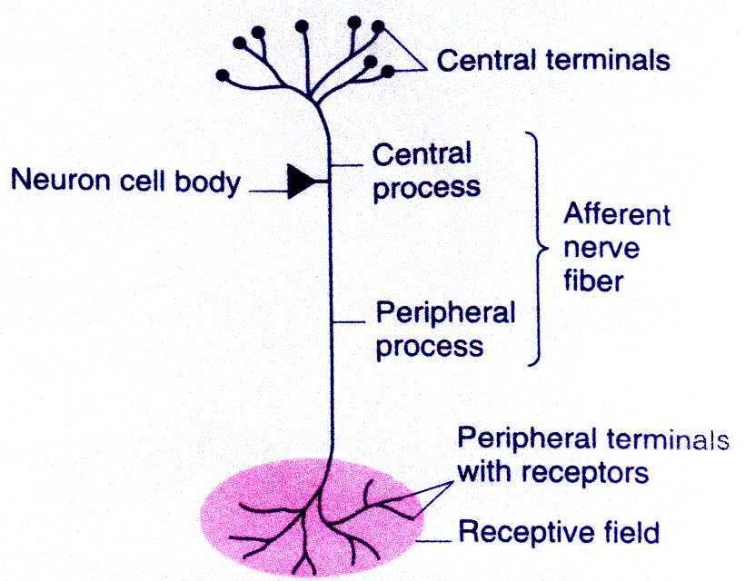

The sensory systems code four aspects of a stimulus: stimulus type, intensity, location and duration. All information from receptors are transmitted in afferent neurons and throughout the nervous system in the form of graded potentials and action potentials.

All sensory information is subject to extensive control at the various synaptic junctions along the ascending pathways before it reaches higher levels of the central nervous system.

Much of the incoming information is reduced or even abolished by inhibition from other neurons in ascending pathways.

The reticular formation and cerebral cortex in particular control much afferent information via descending pathways.

Transient changes in the membrane potential from its resting level produce electric signals that can alter cell activities.

Such changes are the most important way that nerve cells process and transmit information.

These signals occur in two forms: graded potentials and action potentials.

Graded potentials are important in signaling over short distances, whereas action potentials are the long distant signals of nerve and muscle membranes.

A potential is generated across a plasma membrane largely because of the movement of potassium down its concentration gradient through open potassium channels.

In a disease process or where there has been muscle or nerve damage, the opening of the relevant ion channels necessary to transmit information is altered and does not function at optimum strength or capacity.

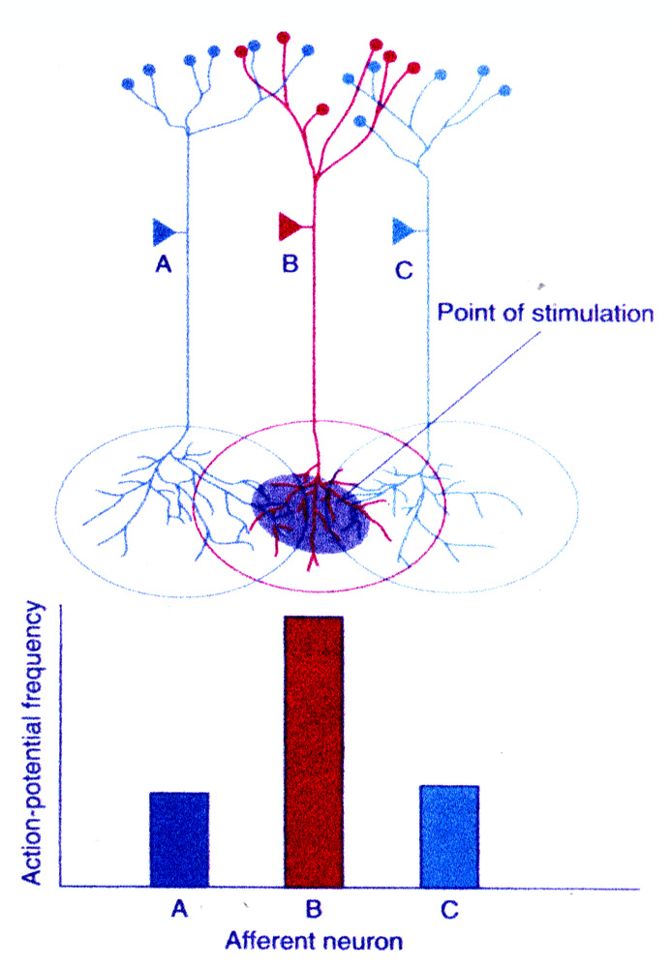

A stimulus point falls within the overlapping receptive fields of three different afferent neurons.

Note the difference in receptor response, the action potential frequency in the three different neurons, due to the difference in receptor distribution.

An afferent neuron responds most vigorously to stimuli applied at the center of its receptive field because the receptor density, that is, the number of receptors in a given area, is greatest there.

The response decreases as the stimulus is moved toward the periphery of the receptive field.

Thus, with Acutouch we are ideally trying to stimulate the center of the receptive field, for maximum effect and benefit to the patient.
With the use of the acutouch pointers we are able to restore the normal movement of ions across plasma membranes and hence assist the electrogenic pump.

This in turn helps to restores normal cell and nerve function.

Since many charged particles are found both inside and outside cells, it is not surprising that the electrical phenomena resulting from the distribution of these charged particles play a significant role in cell function.

Action Potentials

The action potential is the most important discharge of energy or current released in the neuron.

It allows the transmission of this current to proceed along the axon of the neuron to the next synapse and is the normal function of the neuronal cell body and its axon.

When the current reaches the next synapse, it also creates depolarisation and this energy proceeds along the whole neuron like a chain of dominoes.

The next synapse along the neuron may be another gland or muscle and this then releases the bodies natural substances, such as neurotransmitters to the local area, spinal and supraspinal levels or neurohormones into the blood stream, or contraction of muscles may occur according to the locality of the neuron.

The substances and reactions released as a result of the neuronal discharge allows the body to react normally to the constant changes occurring during the activities of homeostasis of the organism.

Injury or disease causes oedema, inflammation, neuronal dysfunction, circulatory disturbances and lack of oxygen supply to the tissues or organ systems.

If there is poor transmission or even cessation of activity along the neuron, as a result of an injury or disease process, the system cannot conduct its action potentials along the neurons and the homeostatic and regenerative mechanisms are disturbed. Inflammation in the tissue promotes the build up of chemical wastes, which may also interfere with neural transmission.

This may be caused by mechanical, chemical or electrical disturbance to the neuronal complex.

If the action potential mechanism can be restored to normal, injury and disease can be affected at a cellular level and the health or normal nerve conduction of the organism can be improved and in certain circumstances, regained.

This is possible with the use of Acutouch therapy.

Acutouch Therapy is therefore multi-faceted:

- It not only increases circulation to damaged tissue but is also able to increase the oxygen carrying capacity of the blood;

- It facilitates the restoration of normal nerve function, which in itself has numerous beneficial effects in the body and;

- Through the stimulation of A delta and C fibres it plays a significant role in pain control.

Western Scientific Approach to Acupuncture

----a modern scientific approach to therapy involving dry needling of tissues, which has developed from the introduction and evaluation of traditional Chinese acupuncture in the west.

Principal difference between traditional eastern and western scientific acupuncture approach is the method of diagnosis, and the pursuit of a scientific rationale for treatment.

It needs to be remembered, however, that a definite diagnosis is often only the result of ongoing reassessment during the treatment process.

Acupuncture owes much of its respectability to the discovery that it releases opioid peptides.

It appears that acupuncture works in a variety of ways:

- By altering autonomic tone.

- By psychoneuroimmuno-modulation.

- By influencing the hypothalamus

- By releasing neuropeptides.

Endogenous opioids are seen to be the mechanism for acupuncture pain control.

Acupuncture is regarded as a neuromodulating input into the CNS. It has multiple analgesia systems into the brain and spinal cord.

Acupuncture analgesia in people and in animals is reversed or abolished by naloxone, under most conditions, showing that its mechanism is opioidergic.

In human subjects in whom pain was relieved by acupuncture, an increase in cerebrospinal fluid beta endorphin levels was noted.

Experiments show that when a nerve is blocked by local anaethesia, acupuncture is ineffective in the territory supplied by the nerve.

Thus, showing that the acupuncture effect is conducted along nerves.

From a modern neuro-physiology perspective, this is perhaps the most important and fundamental piece of information on acupuncture.

Traditional Chinese Acupuncture places great emphasis on the “flow of energy.

It’s physiological equivalent is probably the flow of nerve impulses in the peripheral nervous system.

When the flow of nerve impulses is blocked, innervated nerve structures are deprived of the trophic factor.

The intact nerve, normally delivers this factor thought to be a combination of axonplasmic and electrical input.

It is needed for the regulation and maintenance of cellular function and integrity.

Structures deprived of the trophic factor become highly irritable and develop super-sensitivity.

Acupuncture Points

Acupuncture is said to be effective only at certain points on the body surface, known as acupuncture points.

In fact, comparison with an anatomical atlas shows that many of these points correspond with the points at which small nerve bundles penetrate the fascia. Chang, (1994) cites two Chinese studies showing that 308 acupuncture points are sited on or very close to nerves, while 286 are on or very close to major blood vessels, which are of course, surrounded by small nerve bundles (nervi vasorum)

Meridians - do they exist?

A no of attempts have been made to validate the concept or existence of meridian lines.

Darras injected radioactive technetium into acupuncture points, to prove their existence.

It was found however that the technetium uptake was faster from certain acupuncture points than non-acupuncture points, but that its movement thereafter was explained entirely by the venous system.

There are some meridians that follow the route of known nervous pathways while others follow the route of the lymphatic system, or circulatory system.

Still others follow none of these pathways and are difficult to explain in terms of currently understood neuro-anatomy.

Some interesting observations have been noted in correlating Travell’s trigger point pain referral patterns and known meridian pathways.

Acupuncture/Acutouch is used to treat non-painful and painful conditions

Painful conditions:

- myofacial pain -- trigger point approach to treatment.

- non-myofacial: nociceptive pain and visceral pain --- best approached by segmental acupuncture.

- neurogenic pain ---- direct segmental stim. may be effective but this can often exacerbate the symptoms.

In this case non-segmental acupuncture is usually the best approach (using non-hyperalgesic segments).

- Acute or surgical pain ---- acupuncture used in addition to anesthesia or sedation.

Non-segmental approach is usually the best.

Non-painful conditions are commonly treated with a local or segmental approach.

Or for generalised conditions – a selection of well known traditional points.

Pain Mechanisms
Pain is an experience normally associated with damage or threatened damage to the tissues of the body.
Its physiology involves two processes:
- a peripheral process concerned with the detection and transmission of information concerning tissue damage;
- a central process governing the cerebral response to this information.

Most forms of organic pain arise as a result noxious stimuli to visceral or somatic tissues of the body and can be classified as visceral or somatic pain: In such conditions nociception involves 4 phases:
- transduction ( or the detection of noxious stimuli)
- transmission by the peripheral nervous system
- transmission in the central nervous system
- modulation by the central nervous system

Pain may also arise as a result of nerve injury or disease.
Neurogenic pain does not involve the transduction of a normal noxious stimulus, but nonetheless involves transmission and modulation just the same as visceral or somatic pain do.

Transduction
Noxious stimuli are believed to be detected by free nerve endings in the visceral or somatic tissues.
Their transduction involves either mechanical or chemical processes.
Mechanical nociception occurs whenever collagenous tissues are excessively stretched.
Chemical nociception occurs when nerve endings are exposed to allgogenic chemicals such as hydrogen ions, or potassium ions, serotonin, histamine, bradykinin and adenosine diphosphate.
Such chemicals are liberated in inflammatory responses or from injured cells or accumulate as a result of ischaemia.
It should be noted that in some conditions both mechanical and chemical processes may be active.
In abcesses, the inflammatory process invokes chemical nociception while the tissue swelling causes mechanical nociception.
In trauma the injured tissue liberates intracellular potassium and lysosomal enzymes, but adjacent uninjured tissues may be subjected to excessive mechanical stress.

Peripheral Transmission
Noxious stimuli are not transmitted by any particular modality specific nerve fibres but by a variety of fibres that belong to the A delta and C classes of fibres.
A delta fibres are small diameter, slow conducting myelinated axons that respond differently to mechanical or thermal stimuli.
C fibres are slow conducting, unmyelinated axons and in humans are all polymodal ; in that they respond to mechanical, thermal and chemical stimuli.
A delta and C fibres have in common their small diameter and are referred to collectively as small diameter afferents to distinguish them from large diameter afferents (A beta fibres) that carry the innocuous sensations of touch, vibration and proprioception.

Central Transmission
Upon reaching the spinal cord, small diameter afferents are segregated from large diameter afferents in the dorsal root entry zone.
Large diameter afferents pass medial to the dorsal horn with collaterals ramifying in lamina V of the dorsal grey matter and other branches ascending into the dorsal grey column.
Small diameter afferents conveying nociceptive information divide into collateral branches that ascend and descend in the dorsolateral tract with branches entering superficial layers of the dorsal horn at multiple segments above and below their level of entry into the cord.

Segmental Acupuncutre

Segmental acupuncture involves stimulating peripheral afferent nerves, which run to the same segment of the spinal cord from which the structure under treatment is innervated.

In addition to pain control, segmental acupuncture may also have a role in modulation autonomic function at the same spinal segmental level.

Without a correct understanding of segmental interactions it is difficult to understand why a disease will persist after correct treatment

A segment consists of a dermatome, myotome, sclerotome and viscerotome.

All these are inter-connected by the same-shared innervation, and via this innervation every part of a segment is able to influence any other part of a segment.

In this way, for example, visceral pathology (viscerotome) can manifest itself in the skin (dermatome) and in the muscles and in the joints via viscerocutaneous and visceromotor reflexes.

Conversely, stimulation of the skin or muscles can influence internal organs with the same segmental innervation via cutaneovisceral and musculovisceral reflexes.

This is the basic principle of segmental therapies like acupuncture.

Central modulation of segmental interactions

Principally 2 major supra-spinal relay centres for sensory information where incoming information is processed and modulated:

- Reticular formation.

The RF acts forms a selective filter for information on touch, pain and temperature, as well as visceral info.

- thalamus/hypothalamus

Segmental Symptoms

An increased often nociceptive, activity in one part of a segment can affect all the other parts of the same segment, resulting in segmental symptoms like referred pain, hyperalgesia, hypertonic muscles, activated myofacial trigger points and autonomic symptoms such as vasomotor and trophic changes.

Segmental symptoms can occur in any part of a disturbed segment (dermatome, myotome, sclerotome, or viscerotome) the extent to which these segmental symptoms occur is dependent on:

- duration and severity of the existing pathology

- the amount of central inhibition

- the state of general arousal

- the existence of other pathology in the same segment.

Types of Segmental Symptoms

- pain and hyperalgesia (via the sensory posterior horn and the ascending tracts)

- hypertonic muscles (via the motor anterior horn)

- autonomic symptoms ( via the autonomic lateral horn)

In segmental acupuncture therapy, one aims to use acupuncture points that are neuro-anatomically related to the disturbed segments.

Mechanism of Segmental Acupuncture

The C primary afferent polymodal nociceptors projects to substantia gelatinosa (SG) cells in the superficial dorsal horn; these generate further impulses that pass to, or perhaps dis-inhibit, wide dynamic range cells (WDR) (Or convergent cells) whose axons pass up to the brain in the spinoreticular tract where they are eventually interrupted as painful.

The primary afferent pin prick receptors project both to marginal (M) cells, which project up to the brain in the spinothalamic tract carrying information about pin prick that will become conscious, and to enkephalinergic stalked (St) cells, which can release enkephalins (ENK) that inhibit SG cells, thus preventing information generated by noxious stimulation being further transmitted.

Acupuncture and the Peripheral Nervous System

Western research into acupuncture has concentrated on the neuro-chemical basis of acupuncture analgesia and the central nervous system. In so doing it has ignored the peripheral nervous system and over looked some important clues to acupunctures effectiveness.

This is better known to western practitioners as “intra muscular stimulation.”

Conditions where IMS is indicated, are essentially signs or symptoms of abnormal physiology in the PNS.

These conditions improve when normal function is restored

The needle/ Acutouch is a simple tool to access the PNS to restore normal function.

Acutouch (and IMS) do not treat individual diseases.

The aim is rather to restore complete function and homeostasis.to the patient.
Acutouch and IMS help many conditions by treating one system and restoring normal function to that system ie the PNS.

When a nerve malfunctions, the structures that it supplies become supersensitive and behave abnormally.

There are numerous causes of peripheral nerve damage eg inflammation, trauma and infection.

The damage may be from toxic, metabolic or degenerative conditions.

The nerves response to any agent however is always the same, dysfunction of the nerve.

Non- Segmental Acupuncture

Acupuncuture performed in a noxious manner tends to produce analgesia in regions far distant from the site of the needle. ie acupuncture at certain points can relieve pain in distant regions supplied by nerves from totally different segments.

This is acupunctures non-segmental effect.

Non- segmental acupuncture will be considered under three physio-pharmacological headings:

- The serotonergic system

- The noradrenergic sytem

- Diffuse noxious inhibitory controls

Serotonenergic Mechanism of Acupuncture

Pinprick information is carried up by from marginal cells (M) to the ventroposterior lateral thalamic nucleus, whence it is projected to the cortex and becomes conscious; but in the mid-brain these axons give off a collateral branch to the periaqueductal grey matter (PAG).
The PAG projects down to the nucleus raphe magnus (NRM) in the midline of the medulla oblongata, and this in turn sends serotonergic (%_HT) fibres to the stalked cells (St).
The latter inhibit sustantia gelatinosa cells (SG) by an enkephalinergic mechanism (ENK), and so prevent noxious information arriving in C primary afferent nociceptors from being transmitted to wide dynamic range cells (WDR), deep in the spinal grey matter, which send their axons up to the brain (reticular formatiom, RF)

Opioid endorphinergic fibres descending from the arcuate nucleus in the hypothalamus also influence the PAG and the hypothalamus in return receives projections from the prefrontal cortex

Noradrenergic Mechanism of Acupuncture
Marginal cells (m), activated by A delta pinprick receptors, in addition to their projections to the ventral posterior lateral nucleus and the PAG, also send axon branches to the following:
- subnucleus reticularis dorsalis (R) in the caudal medulla oblongata.
Descending projections from this structure bring about inhibition of noxiously generated information arriving at the spinal cord (SG) in C nociceptors.
This is the diffuse inhibitory noxious control mechanism (DINC) mechanism.
- Nucleus paragigantocellularis lateralis (PGC) which indirectly (via locus coeruleus) brings about noradrenergically mediated inhibition at spinal cord level.
- The locus coerulus at the junction of the medulla oblongata and pons.
Its noradrenergic axons (NAD) are directly inhibitory to those spinal neurons with which they enter into synaptic contact.
(OP =opioid peptides. DCS= dorsal column stimulation.)

Diffuse Noxious Inhibitory Control ( DNIC)
Another mechanism of analgesia involves a noxious stimulus anywhere in the body, and is known as DNIC.
The mechanism of DNIC involves supraspinal loops. (Le Bars et al, 1979)
There are spinal inter-neurons called non-convergent, or nociceptive specific or class 3 neurons, as they respond to noxious stimuli only.
When a noxious stimuli is applied to a particular part of the body, these two types of inter-neurons (lying in the affected segment of the spinal cord) together excite a spino-bulbo loop.
This involves ascending pathways lying in the anterolateral tract that passes upwards to the supraspinal centres, which in turn trigger descending pathways lying within the dorso-lateral tracts of the spinal cord.
These descending tracts inhibit the activities of all the convergent interneurons lying in the segments of the spinal cord innervated by the unaffected regions of the body.

In summary:
Applying a second noxious stimulus may reduce the DNIC produced by one source of noxious stimulation.
The second stimulus is provided fairly rigorously to a region remote from the initial source of pain.
Le Bars, Willer and de Broucker 1992, explain this phenomenon by the idea that the second source of pain, provided by the acupuncture, sets up a second set of DNIC which competes with the first.

Practical

Conditions known to be effective with Acutouch Therapy

- Carpal Tunnel
- Sinusitis
- Osteo- arthritis
- Irritable-bowel
- Nausea (post chemo treament)
- Lower back pain
- Headches/ Migranes
- HIV (secondary symptoms)
- Incontinence
- Musculo-skeletal disorders.
- Asthma/Bronchitis etc
- Strokes

Meridians

Trigger point Therapy

MTP are frequently activated as a result of the muscle being subjected to high-intensity mechanically induced trauma.

Trauma of this severity also damages the surrounding cells, with as a result of this, an associated inflammatory response, liberating chemicals such as histamine, bradykinin, prostoglandins etc.

The effect of the chemicals is to increase the already physically induced nociceptor activation.

The effect in this case of using the Acutouch is not only to provide pain control but also to deal with and eliminate the chemicals producing a chemical nociception of the surrounding tissues.
The Acutouch pointers deal with both the physical and chemical damage.
References

- Medical Acupuncture. A Western Scientific Approach
Edited by Jacqueline Filshie and Adrian White
- Acupuncture A Scientific Appraisal
Edited by Edzard Ernst and Adrain White
- Emotional Intelligence
By Daniel Goleman

- Discovery of Magnetic Health
By George Washnis and Richard Hricak

- Magnetic Healing
By Buryl Payne

- Magnet Therapy
By Ghanshyam Singh Birla and Colette Hemlin

- Acupuncture A Viable Medical Alternative
By Marie Cargill

- Human Physiology
By Vander, Sherman and Luciano

- Review of Medical Physiology
By William F. Gonong

- Clinically Orientated Anatomy
By Keith L. Moore

- Introducing Action Potential Currents
By Phyllis Berger

Combined Effects of Acutouch

1. Pain control

2. Augmented circulation

3. Increased elimination of toxins

4. Enhanced nutrient uptake into the cells

5. Normalization of the Autonomic Nervous System function

6. Mild Alkinization of the blood

7. Anti-inflammatory Effect

8. Improved Oxygen delivery

9. Contains damage done by positively charged Free Radicals.

10. Triggers the Immune response

11. Increases the blood Ca levels

12. Improves the sleep cycle

Dr. Blair Christink
B.Sc.,D.C. (Canada)

